**ST.ANN’S COLLEGE OF ENGINEERING & TECHNOLOGY**

**DEPARTMENT OF ELECTRICAL AND ELECTRONICS ENGINEERING**

(Accredited twice by **NBA**, **IE(I)Kolkata**,**& NAAC** With “**A”** GRADE approved

by AICTE, NEWDELHI & Permanently AFFLIATED TO J.N.T.U.K,KAKINADA)

**2010-2014**

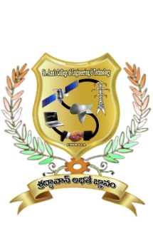

**CERTIFICATE**

This is to certify that the project work entitled **“Control strategy & Mathematical Modeling of BLDC motor in Electric power Steering ”** thatis being submitted by

**Mr.**  bearing **Roll. No:** in partial fulfilment of the requirement for the award of the degree of **Bachelor of Technology in ELECTRICAL AND ELECTRONICS ENGINEERING** of **Jawaharlal Nehru Technological University Kakinada, Kakinada** isa record of bonafide work carried out by himunder my guidance and supervision during the academic year 20132014.

Viva voce date:

**Mr.S.V.D.ANIL KUMAR,M.Tech,Ph.D**

**Head of the Department**

**MS.V.PAVANI M.TECH**

**Project Guide.**

**EXTERNAL EXAMINER**